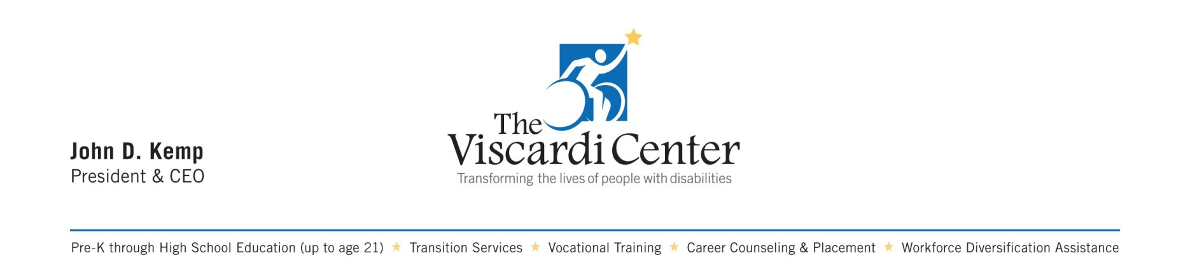

February 24, 2017

Governor Andrew M. Cuomo  
NYS State Capitol Building  
Albany, NY 12224

Re: Opposition to ACA Repeal

Dear Governor Cuomo:

The Viscardi Center, based in Albertson on Long Island, is a network of non-profit organizations that educate, employ and empower children and adults with disabilities so they may be active, financially independent and full participants in our great state of New York. You have been a champion for people with disabilities, and we need your continued support of our rights now more than ever as you head into meetings with fellow Governors.

61 million Americans with disabilities are at risk of losing their health care coverage, benefits and right to live in the community. Along with other disability leaders across the country, I ask you to put people first, over partisan politics. While we have many concerns about a repeal of the Affordable Care Act (ACA) and other cuts to Medicaid services, and the detrimental affect they may have on the health and well-being of people with disabilities and their families/caregivers, let me point to several areas of particular worry:

* **New York, as a Community First Choice (CFC) state, will lose its 6% enhanced Medicaid match.**
* **Cuts to prescription drugs, therapy sessions, Personal Care Attendants, HCBS waivers, state plan amendments, and so called “optional services” may mean the difference between “life and death**” **for many people with disabilities.**
* **People with disabilities who are employed tax payers and seeking financial independence, may have to quit their jobs** due to loss of funds for Personal Care Attendants or access to state optional Medicaid buy-in plans—**only to then require even more public assistance.**
* **The end of enhanced federal matching funds** for the “Money Follows the Person” program that liberated over 63,000 people from institutions, combined with the loss of CFC, **will make it far more difficult for people to avoid institutionalization and nursing homes—resulting in higher government expenses, poorer quality of care and loss of community living.**

*It’s about saving lives and improving health. It’s about independence and community participation. It’s about civil rights, freedom and liberty. We can help improve Medicaid without harming people.* Nothing About Us Without Us.

Help us protect access to affordable, quality health care and long term supports and services.   
